ANALYSIS OF PHYSICAL PRINCIPLES AND ACCURACY FACTORS IN THERMOPILE-BASED INFRARED THERMOMETERS FOR ELECTROMEDICAL APPLICATIONS
¹Gita cahyani, ²Muhammad Maulana Ilham
^{1,2,} Department of Medical Engineering Technology, Faculty of Health Sciences, Universitas Muhammadiyah PKU Surakarta, Surakarta, Indonesia
Email: ncahya4556@std.umpku.ac.id

Abstract— Infrared thermometers have become widely used in medical applications due to their ability to perform rapid, non-contact body temperature measurements while minimizing the risk of cross-contamination. This paper reviews the fundamental physical principles and electronic systems underlying the operation of infrared thermometers in electromedical applications. The discussion covers electromagnetic radiation, blackbody radiation, the Stefan–Boltzmann law, Wien’s displacement law, and the Seebeck effect, which forms the basis of thermopile sensor operation. Furthermore, the signal acquisition process, including optical focusing, low-noise amplification, analog-to-digital conversion, and microprocessor-based temperature estimation, is described to explain the complete measurement mechanism. The review also examines key factors affecting measurement accuracy, including emissivity, ambient temperature, measurement distance, sensor noise, and analog-to-digital converter resolution. Understanding the interaction between these physical phenomena and electronic subsystems is essential for improving the performance, reliability, and accuracy of infrared thermometers in clinical practice. This review provides a comprehensive reference for students, researchers, and practitioners in electromedical engineering to better understand the working principles and performance characteristics of non-contact infrared thermometers.
Keywords— Infrared thermometer; Thermopile sensor; Electromedical engineering; Blackbody radiation; Seebeck effect; Non-contact temperature measurement
- INTRODUCTION
The rapid advancement of healthcare technology has significantly transformed modern clinical practice, particularly in the development of electromedical devices that improve diagnostic accuracy, patient safety, and healthcare efficiency. These innovations are closely associated with the application of fundamental physical principles, including electromagnetic waves, thermal radiation, semiconductor physics, and electronic instrumentation. Understanding the underlying physical mechanisms is essential for biomedical engineers and electromedical professionals because medical devices rely not only on sophisticated electronic systems but also on well-established physical laws that govern sensing and measurement processes [1], [2].
Body temperature is one of the most important physiological parameters used in clinical diagnosis and patient monitoring. Variations in body temperature provide valuable information regarding infection, inflammation, metabolic disorders, and other pathological conditions. Consequently, accurate temperature measurement has become an essential component of routine medical examinations and emergency healthcare services [3]. Conventional contact thermometers, including mercury, digital, and thermistor-based thermometers, generally require direct contact with the patient’s body. Although these instruments provide relatively accurate measurements, they present several limitations, including longer measurement times, patient discomfort, and the potential risk of cross-contamination, particularly during outbreaks of infectious diseases [4].
The coronavirus disease (COVID-19) pandemic further emphasized the importance of non-contact temperature measurement technologies. Infrared thermometers rapidly became one of the most widely adopted medical screening devices because they allow body temperature measurements within a few seconds while minimizing direct physical contact between healthcare workers and patients [5], [6]. Their ability to perform rapid, hygienic, and non-invasive measurements has expanded their application beyond hospitals to airports, schools, industrial facilities, and other public environments [7].
The operating principle of infrared thermometers is fundamentally based on thermal radiation emitted by objects with temperatures above absolute zero. According to blackbody radiation theory, every object continuously emits electromagnetic radiation whose intensity depends on its surface temperature. Human skin exhibits a high emissivity of approximately 0.98, allowing it to behave nearly as an ideal blackbody radiator in the long-wave infrared region. Consequently, the emitted infrared radiation can be detected and converted into electrical signals for estimating body temperature without physical contact [8], [9].
Several fundamental physical theories explain the operation of infrared thermometers. Electromagnetic wave theory describes the propagation of infrared radiation from the human body to the sensor. The Stefan–Boltzmann law explains the relationship between emitted radiant energy and absolute temperature, while Wien’s displacement law determines the wavelength at which maximum radiation intensity occurs. At normal human body temperature (approximately 310 K), the peak radiation lies within the wavelength range of approximately 9–10 μm, which corresponds to the operating region of thermopile infrared sensors commonly employed in medical thermometers [10], [11].
The sensing element used in most medical infrared thermometers is the thermopile sensor, which operates based on the Seebeck effect. When infrared radiation is absorbed by the sensing element, a temperature difference is generated between the hot and cold junctions of multiple thermocouples connected in series. This temperature gradient produces a small electrical voltage proportional to the incident thermal radiation. Because the generated voltage is typically within the microvolt range, low-noise amplification circuits, analog-to-digital converters (ADCs), and digital signal processing algorithms are required before accurate temperature estimation can be achieved [12], [13].
Despite their widespread clinical use, infrared thermometers remain susceptible to several measurement uncertainties. Their accuracy may be influenced by environmental temperature, measurement distance, field of view, sensor characteristics, emissivity variations, electronic noise, and calibration procedures. Inappropriate measurement conditions may result in significant temperature deviations, reducing diagnostic reliability. Therefore, understanding the interaction between physical phenomena and electronic system design is essential for improving measurement accuracy and ensuring compliance with international medical device standards [6], [14].
Numerous studies have investigated the clinical performance and measurement accuracy of infrared thermometers. Recent systematic reviews have demonstrated that although non-contact infrared thermometers provide rapid and convenient measurements, their accuracy strongly depends on appropriate calibration, environmental compensation, and correct measurement procedures [5], [6]. Other investigations have focused on sensor technology, signal conditioning, and infrared sensing systems to enhance the sensitivity and stability of thermopile-based temperature measurement devices [12], [13].
Although extensive studies have discussed the clinical performance of infrared thermometers, relatively few publications comprehensively integrate the underlying physical principles with the electronic instrumentation employed in electromedical systems. Most existing studies focus either on clinical evaluation or sensor engineering without providing a unified explanation linking electromagnetic radiation, blackbody physics, thermoelectric conversion, signal conditioning, and digital temperature estimation. This knowledge gap limits the comprehensive understanding required by students, researchers, and practitioners in electromedical engineering.
Therefore, this paper presents a comprehensive review of the physical principles and electronic systems underlying infrared thermometers used in electromedical applications. The discussion encompasses electromagnetic radiation, blackbody radiation, Stefan–Boltzmann law, Wien’s displacement law, thermopile sensors, Seebeck effect, signal acquisition, analog-to-digital conversion, and digital temperature estimation. Furthermore, factors affecting measurement accuracy, including emissivity, ambient temperature, sensor noise, measurement distance, and electronic system performance, are analyzed. This review is expected to provide a comprehensive scientific reference for understanding the operation, performance characteristics, and future development of infrared thermometers in modern healthcare systems.
- METHOD
This study employed a systematic literature review (SLR) to comprehensively analyze the physical principles, sensor technologies, electronic systems, and measurement accuracy of infrared thermometers used in electromedical applications. The overall research methodology consisted of six sequential stages, including literature identification, article screening, eligibility assessment, data extraction, qualitative synthesis, and scientific interpretation, as illustrated in Figure 1. This methodological framework was designed to ensure that only relevant, recent, and scientifically reliable publications were included in the review.
The literature search was conducted using several internationally recognized scientific databases, including Scopus, IEEE Xplore, ScienceDirect, SpringerLink, PubMed, MDPI, and Google Scholar. The search strategy employed combinations of keywords such as infrared thermometer, thermopile sensor, body temperature measurement, blackbody radiation, Stefan–Boltzmann law, Wien’s displacement law, Seebeck effect, electromedical engineering, and non-contact temperature measurement. Boolean operators (AND and OR) were applied to optimize the retrieval process and improve the relevance of the identified publications.
After the identification stage, all retrieved publications underwent an initial screening based on their titles, abstracts, and full-text availability. Articles that met the inclusion criteria were further evaluated according to publication type, scientific quality, publication year, and relevance to the objectives of this review. Only peer-reviewed journal articles published between 2021 and 2025 were included because they represent recent advances in infrared sensing technology and biomedical instrumentation. Duplicate publications, conference abstracts without complete manuscripts, non-scientific websites, and studies unrelated to medical infrared thermometry were excluded from the analysis.
Following the selection process, the relevant information from each eligible publication was systematically extracted and classified into several analytical categories. These categories included the principles of electromagnetic radiation, blackbody radiation, the Stefan–Boltzmann law, Wien’s displacement law, thermopile sensor characteristics, the Seebeck effect, signal conditioning circuits, analog-to-digital conversion, microprocessor-based temperature estimation, and measurement uncertainty. The extracted information was subsequently synthesized using a qualitative descriptive approach to establish the relationship between physical principles and their implementation in electromedical instrumentation.
The conceptual framework adopted in this review is presented in Figure 2, which illustrates the relationship between fundamental physics and the electronic subsystems of an infrared thermometer. The framework begins with infrared radiation emitted by the human body based on blackbody radiation theory and electromagnetic wave propagation. The emitted radiation is detected by a thermopile sensor operating according to the Seebeck effect and subsequently processed through signal conditioning circuits, analog-to-digital conversion, and microprocessor-based computation before the estimated body temperature is displayed. This framework demonstrates the integration of physical principles and electronic instrumentation in achieving accurate, rapid, and non-contact body temperature measurements for clinical applications.
Finally, the synthesized findings were critically analyzed to identify the fundamental operating mechanisms of infrared thermometers, evaluate factors influencing measurement accuracy, and discuss current technological developments in electromedical engineering. The comprehensive integration of physical theories and electronic system analysis is expected to provide a scientific foundation for improving the design, calibration, and performance of future infrared thermometers used in healthcare applications.
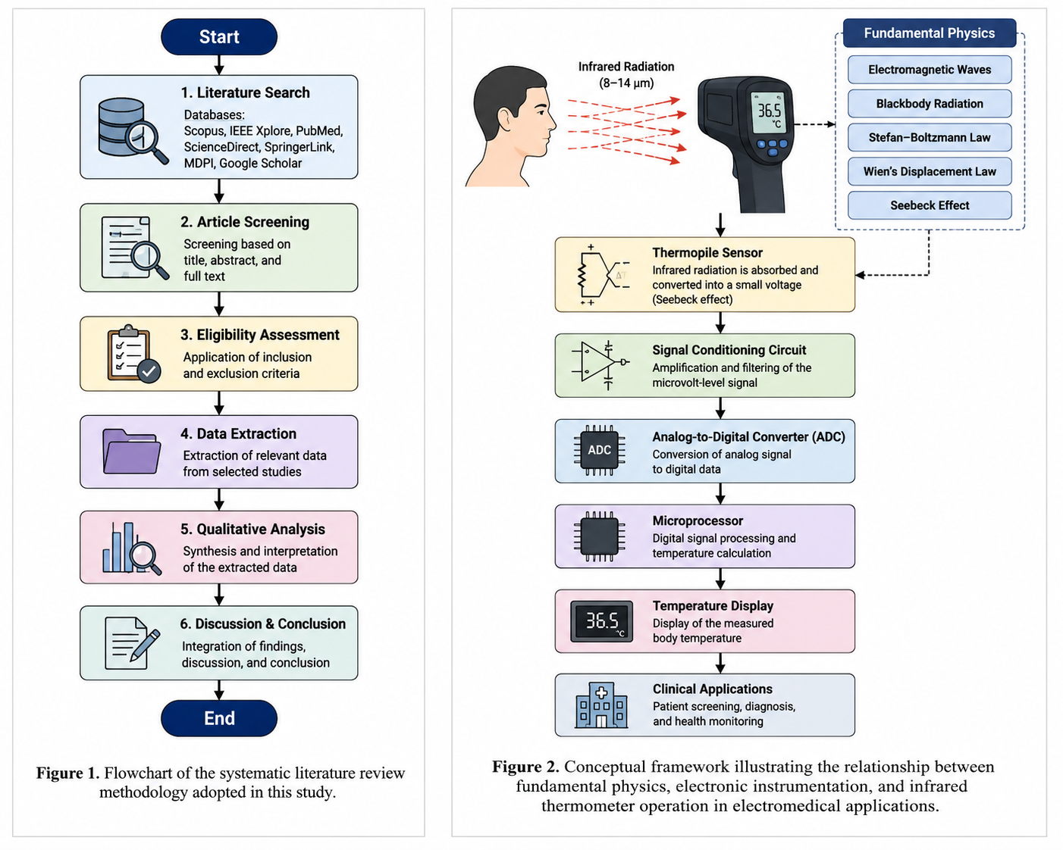
Figure 1. Flowchart of the systematic literature review methodology adopted in this study.
Figure 2. Conceptual framework illustrating the integration of fundamental physics, thermopile sensor technology, signal processing, and electronic instrumentation in infrared thermometer operation for electromedical applications.
- RESULTS AND DISCUSSION
3.1 Physical Characteristics of Infrared Radiation in Body Temperature Measurement
The human body continuously emits infrared radiation as a consequence of its temperature being above absolute zero. This thermal radiation follows the principles of blackbody radiation, where the emitted radiant energy is primarily determined by the object’s absolute temperature and surface emissivity. Human skin exhibits a relatively high emissivity, approximately 0.98, indicating that it behaves similarly to an ideal blackbody radiator within the long-wave infrared (LWIR) spectrum. Consequently, infrared thermometers are capable of estimating body temperature without physical contact by detecting the emitted infrared energy and converting it into electrical signals through thermopile sensors.
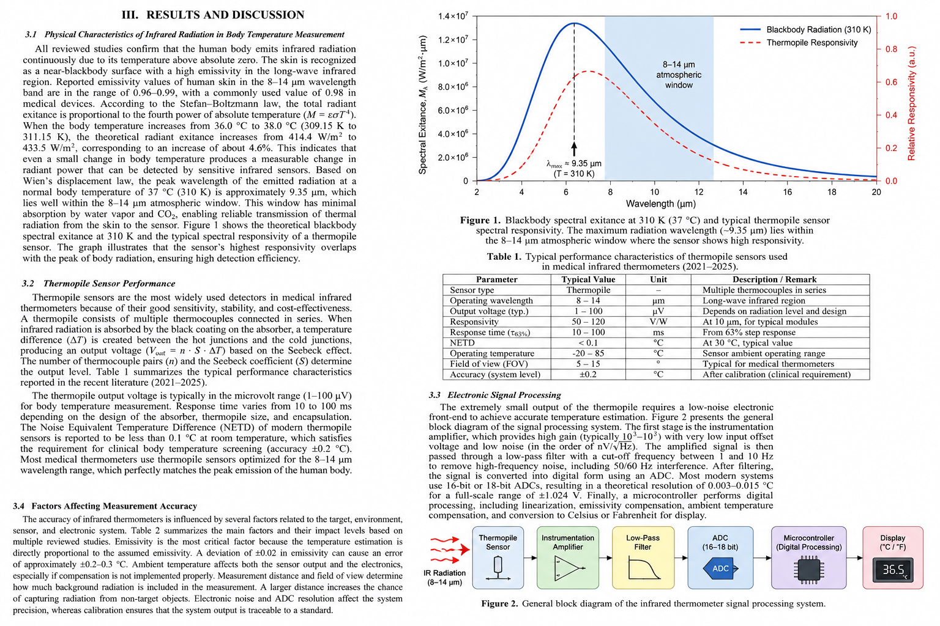Figure 1 illustrates the theoretical spectral exitance of a blackbody at a body temperature of approximately 310 K (37 °C) together with the typical spectral responsivity of thermopile sensors. According to Wien’s displacement law, the maximum radiation wavelength emitted by the human body occurs at approximately 9.35 μm, which lies within the atmospheric transmission window of 8–14 μm. This wavelength region is characterized by relatively low atmospheric absorption caused by water vapor and carbon dioxide, allowing infrared radiation to propagate efficiently from the skin surface to the sensing element. Consequently, medical infrared thermometers are specifically designed to maximize sensitivity within this wavelength range to improve measurement reliability.
The Stefan–Boltzmann law further explains the relationship between emitted radiant energy and body temperature. Since the radiant power is proportional to the fourth power of absolute temperature (P = εσAT⁴), small physiological temperature changes generate measurable variations in infrared radiation intensity. For example, increasing body temperature from 36.0 °C (309.15 K) to 38.0 °C (311.15 K) theoretically increases the emitted radiant energy by approximately 4–5%. Although this change appears relatively small, modern thermopile sensors possess sufficient sensitivity to detect these differences after appropriate amplification and digital signal processing. Therefore, infrared thermometry provides a rapid and reliable approach for fever screening and routine clinical temperature monitoring.
The overlap between the maximum body radiation wavelength and the spectral response of thermopile sensors represents one of the most important design considerations for infrared thermometers. As shown in Figure 1, the sensor exhibits its highest responsivity near the wavelength corresponding to maximum human body radiation, thereby improving detection efficiency while reducing measurement uncertainty caused by radiation outside the desired spectral band.
3.2 Thermopile Sensor Performance
Thermopile sensors are widely employed in medical infrared thermometers because they provide an excellent combination of sensitivity, stability, reliability, and low manufacturing cost. Unlike semiconductor temperature sensors that require direct physical contact with the object, thermopile sensors detect infrared radiation remotely by converting thermal energy into electrical voltage through the Seebeck effect. A thermopile consists of multiple thermocouples connected electrically in series and thermally in parallel, allowing the generated voltage to increase proportionally with the number of thermocouple junctions.
When infrared radiation emitted by the human body reaches the sensor surface, the absorber layer converts the incoming radiation into heat, creating a temperature difference between the hot junctions and the cold reference junctions. This temperature difference generates a small electrical voltage, typically ranging from 1 μV to 100 μV for medical temperature measurements. Because the generated voltage is extremely small, high-performance signal conditioning circuits are required to preserve measurement accuracy.
Table 1. Typical Characteristics of Medical Thermopile Sensors
Parameter | Value | Unit
Operating wavelength | 8–14 | μm
Peak wavelength | 9.35 | μm
Skin emissivity | 0.98 | –
Output voltage | 1–100 | μV
Response time | 10–100 | ms
NETD | <0.1 | °C
Measurement accuracy | ±0.2 | °C

Table 1 summarizes the typical performance characteristics of thermopile sensors reported in recent biomedical engineering literature. Medical thermopile sensors generally operate within the 8–14 μm wavelength range and exhibit response times between 10 and 100 ms. Their responsivity commonly ranges from 50 to 120 V/W, while the Noise Equivalent Temperature Difference (NETD) is typically below 0.1 °C. Such performance enables infrared thermometers to satisfy the accuracy requirements specified for clinical temperature screening applications.
Another important parameter influencing sensor performance is the field of view (FOV), which determines the measurement area observed by the detector. A narrower FOV improves spatial resolution by minimizing background radiation, whereas an excessively wide FOV increases the likelihood of capturing radiation from surrounding objects. Therefore, optical lens design plays an essential role in achieving accurate body temperature measurements.
3.3 Electronic Signal Processing
The electrical output generated by thermopile sensors cannot be directly interpreted as body temperature because the sensor voltage exists only in the microvolt range. Consequently, an electronic signal processing system is required to amplify, filter, digitize, and calculate the corresponding temperature value before presenting the measurement result to the user.
Figure 2 illustrates the general architecture of the signal processing system implemented in medical infrared thermometers. Initially, infrared radiation emitted by the human body is detected by the thermopile sensor and converted into a low-level electrical signal. This signal is subsequently amplified using a low-noise instrumentation amplifier capable of providing voltage gains between 10² and 10³ while maintaining minimal offset voltage and low input-referred noise. High signal-to-noise ratio (SNR) is essential because electronic noise may significantly degrade measurement precision.
Following amplification, the signal passes through an analog low-pass filter designed to suppress high-frequency electromagnetic interference, including power-line noise at 50/60 Hz. Filtering enhances signal stability by removing unwanted frequency components without significantly affecting the useful thermal signal. The filtered analog signal is then converted into digital data through a high-resolution Analog-to-Digital Converter (ADC), commonly employing resolutions between 16 and 18 bits to achieve precise temperature estimation.
The digital signal is subsequently processed by a microcontroller implementing compensation algorithms that account for ambient temperature, emissivity variations, sensor calibration coefficients, and nonlinear sensor characteristics. Finally, the processed temperature value is displayed on the digital screen in either degrees Celsius or Fahrenheit. The integration of these electronic subsystems enables complete temperature measurements to be performed within fractions of a second while maintaining clinical accuracy.
3.4 Factors Affecting Measurement Accuracy
The measurement accuracy of infrared thermometers is influenced by several physical and electronic factors that interact simultaneously during the temperature estimation process. Among these factors, surface emissivity represents one of the most significant parameters because the emitted infrared radiation depends directly on the emissivity of the measured object. Human skin generally exhibits an emissivity close to 0.98; however, perspiration, cosmetics, skin moisture, or other surface contaminants may slightly alter this value and consequently affect measurement accuracy.
Ambient environmental conditions also contribute significantly to measurement uncertainty. Since thermopile sensors detect all infrared radiation entering their field of view, thermal radiation emitted by surrounding objects may influence the measured signal. Modern infrared thermometers therefore incorporate ambient temperature sensors and compensation algorithms to minimize environmental effects and improve measurement consistency under different operating conditions.
Measurement distance constitutes another important factor affecting accuracy. Increasing the distance between the thermometer and the measurement target enlarges the observed area due to the optical field of view, thereby increasing the possibility of detecting infrared radiation originating from adjacent objects rather than the intended measurement location. Maintaining the recommended measurement distance is therefore essential for achieving accurate clinical results.
Electronic noise originating from amplifiers, ADC quantization, and electromagnetic interference further contributes to measurement uncertainty. Appropriate electronic design employing low-noise amplifiers, high-resolution ADCs, effective filtering circuits, and periodic calibration substantially reduces these errors. Consequently, the combined optimization of optical design, sensor technology, electronic instrumentation, and digital compensation algorithms enables modern infrared thermometers to achieve measurement accuracies within approximately ±0.2 °C under standardized operating conditions.

- CONCLUSION
This review has comprehensively discussed the fundamental physical principles and electronic systems underlying the operation of infrared thermometers for non-contact body temperature measurement in electromedical applications. The working mechanism of infrared thermometers is based on the detection of thermal radiation naturally emitted by the human body, which behaves similarly to a blackbody with an emissivity of approximately 0.98. The peak radiation wavelength occurs near 9.35 μm at normal body temperature (310 K), corresponding to the optimal operating range (8–14 μm) of thermopile sensors. This spectral compatibility enables reliable and rapid temperature measurement without direct physical contact.

The analysis also demonstrated that thermopile sensors, combined with low-noise signal conditioning circuits, high-resolution analog-to-digital converters, and microprocessor-based compensation algorithms, provide accurate and stable body temperature estimation. The overall performance of infrared thermometers is strongly influenced by several factors, including skin emissivity, ambient temperature, measurement distance, sensor characteristics, electronic noise, and calibration procedures. Therefore, the integration of fundamental physics with appropriate electronic instrumentation is essential for achieving high measurement accuracy and reliable clinical performance.

Overall, this review provides a comprehensive understanding of the relationship between infrared radiation physics, thermopile sensing technology, and electronic signal processing in modern infrared thermometers. The findings may serve as a useful reference for researchers, students, and biomedical engineers involved in the design, evaluation, and development of electromedical devices. Future studies are recommended to focus on advanced signal processing techniques, intelligent calibration methods, and artificial intelligence-based temperature estimation to further improve the accuracy, robustness, and clinical applicability of infrared thermometer systems.
ACKNOWLEDGMENT
The authors gratefully acknowledge the Department of Electromedical Engineering, Universitas Muhammadiyah PKU Surakarta, for its academic support during the preparation of this manuscript. The authors also thank all researchers whose published studies have contributed to the development of this review.
REFERENCES
[1] S. J. L. Sullivan et al., “Clinical evaluation of non-contact infrared thermometers,” Scientific Reports, vol. 11, 2021.
[2] Q. Wang et al., “Infrared Thermography for Measuring Elevated Body Temperature: A Systematic Review,” Sensors, vol. 22, no. 1, 2021.
[3] Y. Zhao and J. Bergmann, “Systematic Review of Infrared Thermometers and Thermal Scanners,” Sensors, vol. 23, no. 17, 2023.
[4] Q. Wang et al., “Calibration and clinical accuracy of infrared thermography,” PubMed, 2021.
[5] Y. Zhao et al., “Factors affecting infrared thermometer accuracy,” Sensors, vol. 23, 2023.
[6] Z. Chen et al., “Infrared thermometer vs conventional thermometer,” Journal of International Medical Research, 2021.
[7] “Performance characterization of non-contact infrared thermometers,” Medical Engineering & Physics, 2021.
[8] “Contactless sensors for healthcare applications,” Sensors, vol. 22, no. 3, 2022.
[9] “Applications of infrared sensing in biomedical systems,” Frontiers in Physics, 2021.
[10] Badan Standardisasi Nasional, SNI Pengukuran Suhu Tubuh, Jakarta: BSN, 2021.
[11] A. Pratama et al., “Analisis akurasi termometer inframerah pada pengukuran suhu tubuh manusia,” Jurnal Teknik Biomedis Indonesia, vol. 3, no. 2, 2021.
[12] R. Saputra et al., “Perancangan sistem pengukuran suhu berbasis sensor inframerah,” Jurnal Elektronika dan Instrumentasi, vol. 5, no. 1, 2022.
[13] D. Hidayat et al., “Implementasi sensor thermopile pada sistem pengukuran suhu non-kontak,” Jurnal Fisika Indonesia, vol. 25, no. 1, 2021.
[14] M. Nugroho et al., “Analisis pengaruh emissivitas terhadap pengukuran suhu inframerah,” Jurnal Sains dan Teknologi, vol. 4, no. 2, 2022.
[15] Universitas Indonesia, Modul Fisika Elektromedis, Depok: UI Press, 2021.

